|  |
| --- |
| Functional Design Document |
| CHG228033: |
| TMEC: RI – Contract Enhancements V1 |
| Markets: All |
| Release: RLS000700 (Jun’22) |



Contents

A. Document approval 3

B. Revision history 3

1. Business Process Overview 4

1.1 Process Overview 4

1.2 Impact Matrix 4

2. Description of the functional change 5

2.1 Changes in Siebel Sales 5

2.2 English Captions 8

2.3 Changes in the ETL 8

2.3.1. Initial Loads/Massive Data updates 9

2.3.2. Performance test/Indexes creation 9

2.4 Changes in BI 9

2.5 Data Dictionary 10

2.6 Changes in Data Interfaces 10

2.6.1. Inbound 10

2.6.2. Outbound 11

2.6.3. Initial Loads 11

2.6.4. Performance test / Indexes creation 11

2.7 Changes in Batch Processes / Aggregations / DRP 12

2.8 Use Case 12

# Document approval

*List members from market, DBU, BTS, ODC, GTC and other teams that are accountable and responsible for the CHG implementation. Add extra rows if required to include extra team members (e.g. responsible for different areas or services).*

|  |  |  |
| --- | --- | --- |
| Role | Name | Function |
| **DBU Approver** | Sergio Campos | Digital CX Manager |
| **BTS expert** | Iker Fernández | BTS TME Manager |
| **BTS expert** | Marta Nuño | BTS TME Manager |
| **BI expert** | Belén Prol | BTS BI Manager |
| **ODC expert** | Ignacio Encinas/David Gallego | ODC Sales |
| **ODC expert** | Miguel Lopez | ODC Data |
| **ODC expert** | Carlos Díaz | Mobile Application |
| **GTC expert** | Jose Carlos Martin | TME Tech Arch Mgr |

This is to confirm that we have reviewed the functional specifications for the proposed solution. We agree with its contents and understand that the technical specifications will be designed based on this approved document.

# Revision history

|  |  |  |  |  |
| --- | --- | --- | --- | --- |
| Revision | Section(s) | Description | Editor | Date |
| 1.0 | - | Draft | Iker Fernández | 11/03/2022 |
| 2.0 |  | Include Legal Entity field in Contracts | Iker Fernández | 14/03/2022 |
|  |  |  |  |  |
|  |  |  |  |  |
|  |  |  |  |  |
|  |  |  |  |  |
|  |  |  |  |  |
|  |  |  |  |  |

# Business Process Overview

## Process Overview

*Provide brief and meaningful information about the requested change, explain current situation, and estimated future improvements. Use Description, Benefits and Impact provide by market in the CHG.*

With the implementation of TME Connect we want to achieve standardization of the processes and get the integration with a new mobile application.

**TOPICS:**

* Contract Terms:
  + Benefit Type field, will be made optional.
  + Enable Benefit Type for KA & Chain contracts.
  + Hide Distribution applet some views.
  + New field to cover Target, a field that is not dependent on unit price.
* Include Legal Entity in Contracts
* Enable functionality for V2/V3 markets for CHG213427 and CHG213217
* Process to Inform Contracted Flag
* New fields Created and Created By for Contracts and Payments

## Impact Matrix

|  |  |
| --- | --- |
| GRM Functionality | Contracts |
| Impact Current Functionality? | Yes |
| Markets Affected | All |
| Applications Affected | Sales / Data / BI |
| Risk of Implementing the change | Low |

# Description of the functional change

## Changes in Siebel Sales

*Explain required changes in Siebel Sales application. Provide names of the views, applets, fields, buttons, etc. Provide screenshots and wireframes of the estimated location for new object or in case of location change.*

1. New attribute **JTI Legal Entity** to be included in all **Contracts (Independent, KA, Chain) t**o be able to link a contract with a legal entity.

|  |  |  |  |  |  |
| --- | --- | --- | --- | --- | --- |
| **BC** | **Field** | **Table / MVL** | **Column / Destination Field** | **Type** | **Picklist** |
| **Contract**  JTI JTI Service Agreement | JTI Legal Entity Id | S_DOC_AGREE | X_LEGAL_ENTITY_ID  (FK to CX_LEGAL_ENTITY | ID |  |
| JTI Legal Entity Name | CX_LEGAL_ENTITY | X_LEGAL_NAME_TEXT | Text |  |
| **KA Contract**  JTI Service Agreement - KA | JTI Legal Entity Id | S_DOC_AGREE | X_LEGAL_ENTITY_ID  (FK to CX_LEGAL_ENTITY | ID |  |
| JTI Legal Entity Name | CX_LEGAL_ENTITY | X_LEGAL_NAME_TEXT | Text |  |
| **Chain Contract**  JTI Service Agreement Chain; | JTI Legal Entity Id | S_DOC_AGREE | X_LEGAL_ENTITY_ID  (FK to CX_LEGAL_ENTITY | ID |  |
| JTI Legal Entity Name | CX_LEGAL_ENTITY | X_LEGAL_NAME_TEXT | Text |  |

“Legal Entity Name” field to be included in the Contract Form in the following applets:

Behaviour should be similar to other fields in the header of the contract in terms of edition/read only, so that user can inform it when creating a contract.

Field to be added to the State Model fields, so that market can set it up as required.

* JTI Agreement Detail Applet - New
* JTI Agreement Detail Applet Chain
* JTI Agreement Detail Applet – KA

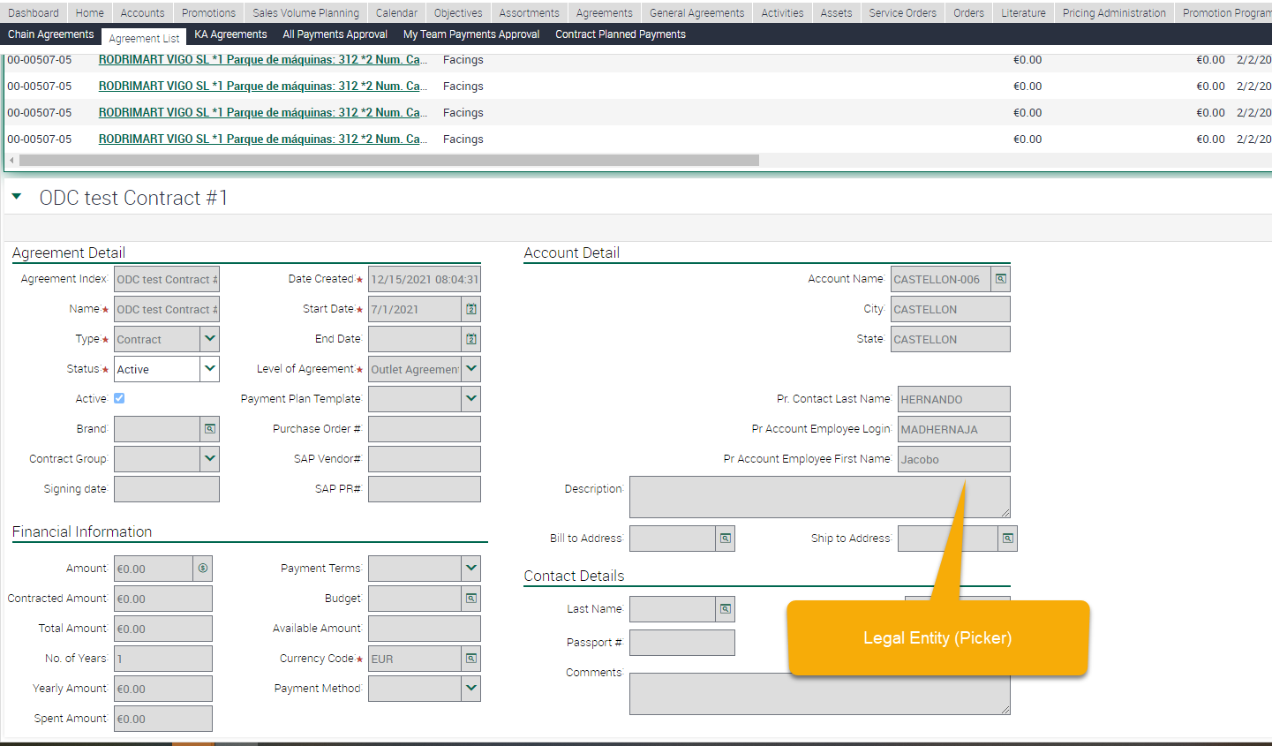

1. New attribute **JTI Target** to be included in the **Contract Items** object, to be able to specify a target amount, without impacting amount to be paid.

Field should be editable in the same way as Price or Quantity fields.

This field to be translated only to V1 & V2 markets so they do not appear for rest of markets. (There is no impact on functionality to expose these fields before go live)

Field also should be available to be displayed in the Compliance Check entity in read only (retrieved by join)

|  |  |  |  |  |  |
| --- | --- | --- | --- | --- | --- |
| **BC** | **Field** | **Table / MVL** | **Column / Destination Field** | **Type** | **Picklist** |
| **Contract Item**  JTI Contract Agreement Item; | JTI Target Num | S_AGREE_ITEM | X_TARGET_NUM | Numeric |  |
| **Contract Compliance**  JTI JTI Agreement Item Compliance  JTI Agreement Item Compliance - New | JTI Target Num | CX_ACT_AGR_ITEM | X_TARGET_NUM (can be retrieved by join from the contract term) | Numeric |  |

1. The following changes must be applied in Contract Terms screens:

**Include below fields in following screens:**

* **Target (JTI Target Num) , to be included hidden by default.**

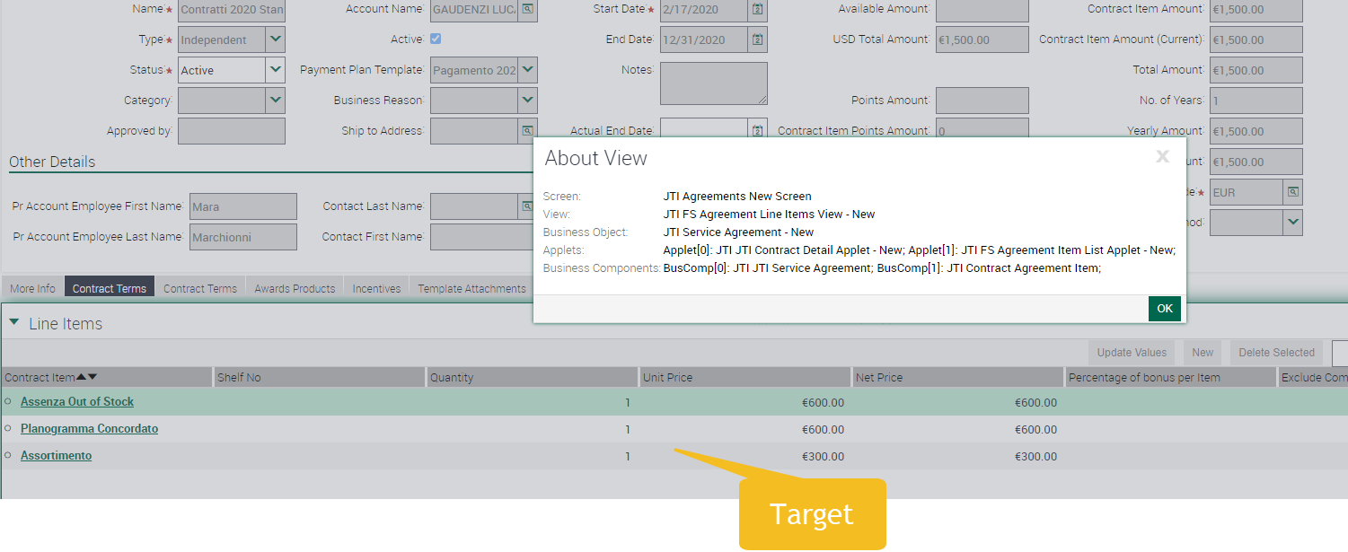

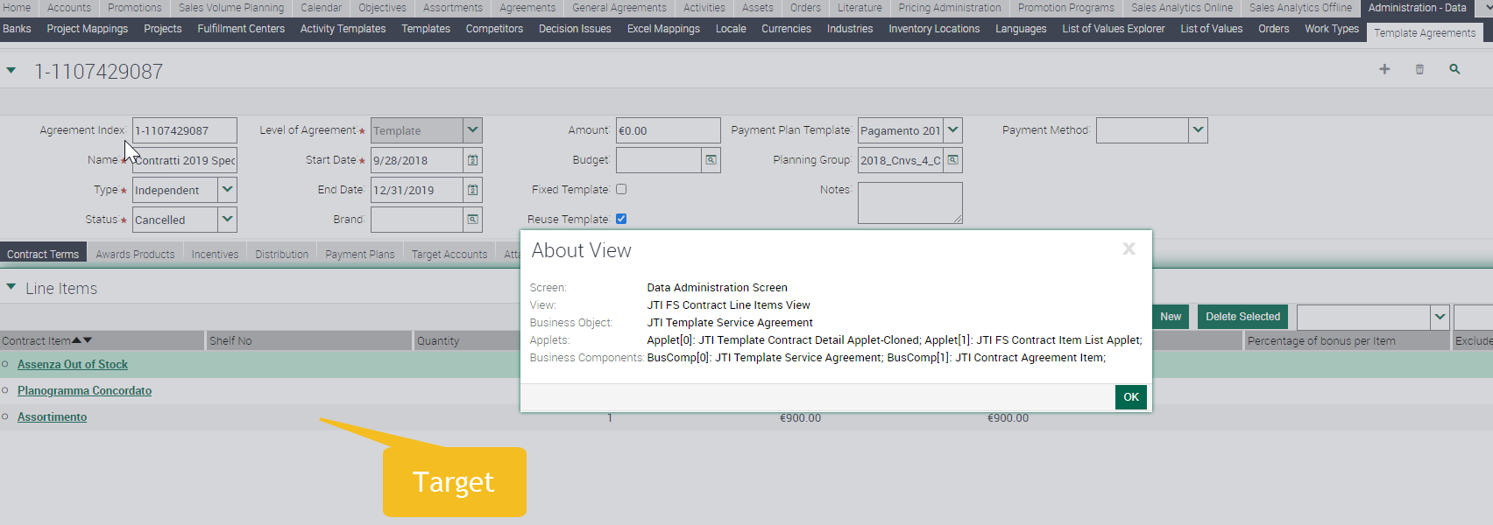

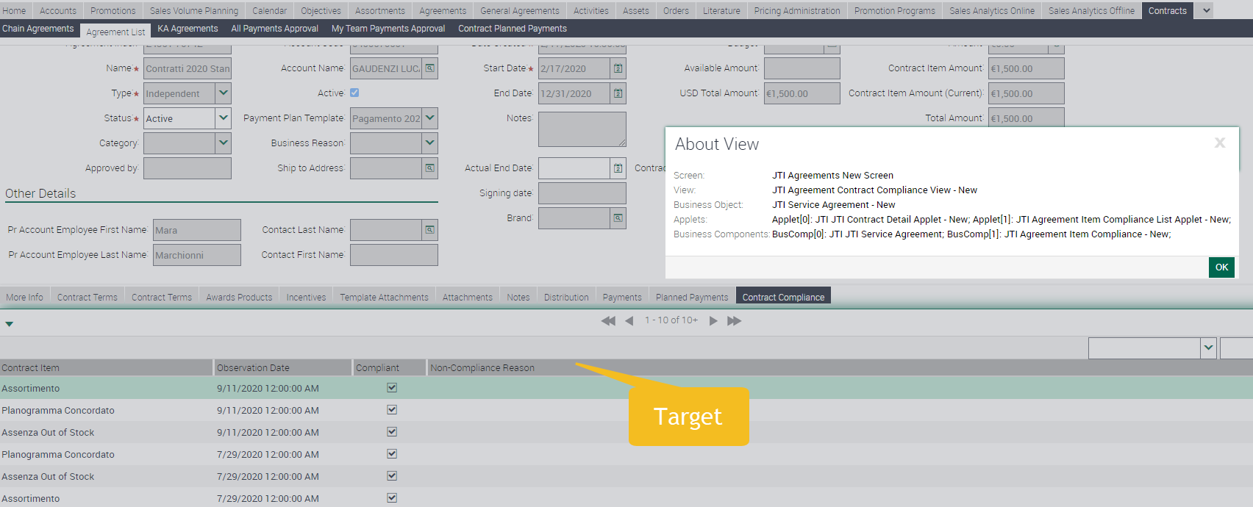

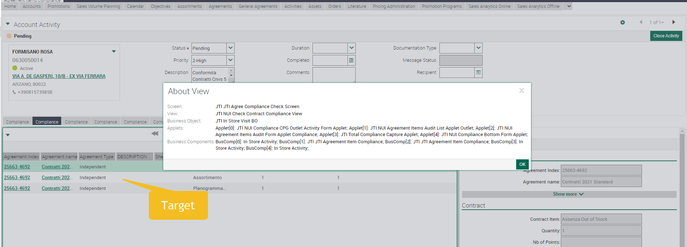

1. Field **Benefit Type** in Contract Terms, should be **made optional**. This way it will be avoided a massive data load for the incoming markets on TME Connect.
   1. This field will be optional in both entities Contract Templates and Contracts.

Additionally field “Benefit Type” already included on independent contracts, to be included in the following BCs and applets:

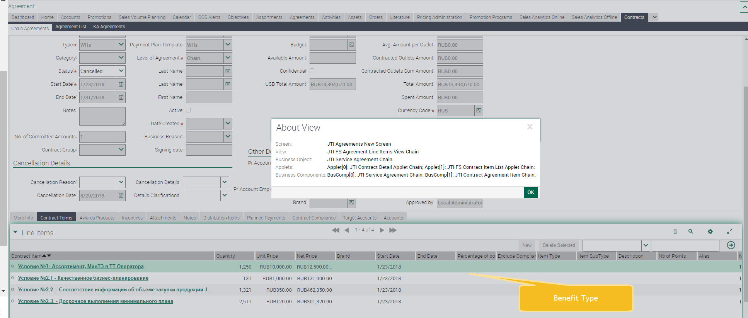

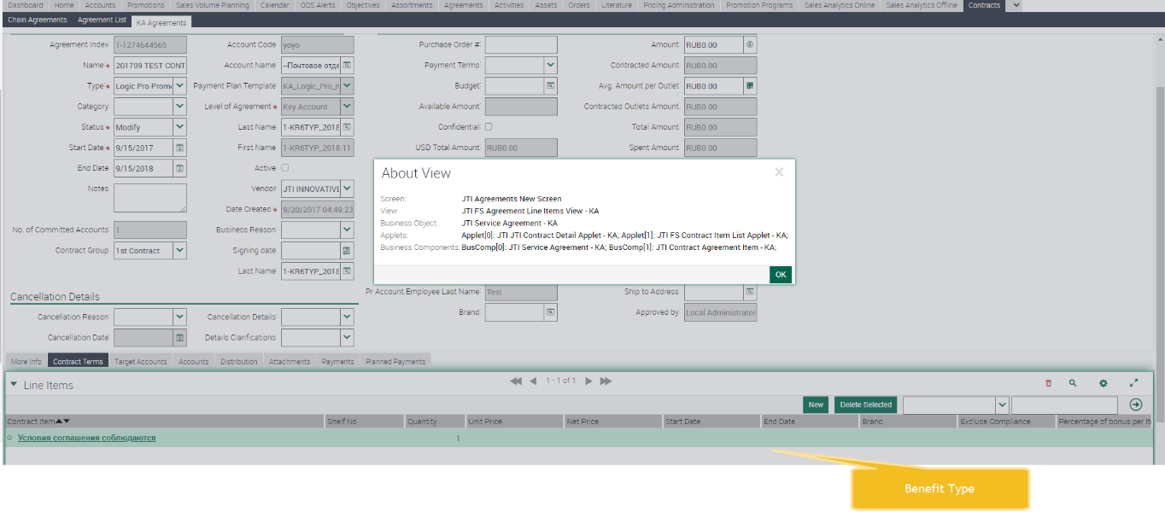

|  |  |  |  |  |  |
| --- | --- | --- | --- | --- | --- |
| **BC** | **Table** | **Field** | **Column** | **Type** | **LOV** |
| JTI Contract Agreement Item Chain | S_AGREE_ITEM | Benefit Type | X_BENEFIT_TYPE | LOV | JTI_BENEFIT_TYPE |
| JTI Contract Agreement Item - KA | S_AGREE_ITEM | Benefit Type | X_BENEFIT_TYPE | LOV | JTI_BENEFIT_TYPE |

1. **Hide Distribution** applet under Contract Terms, in the following views:
   * + - JTI FS Contract Line Items View;
       - JTI FS Agreement Line Items View – New;
2. Functionality for **CHG213427**_TMEC_RI_Enhancements_on_Contracts_&_Contract_Terms should be activated for the following markets:

* Czech
* Hungary
* Slovakia
* Russia
* Kazakhstan

1. Functionality for **CHG213217**_TMEC_RI_Enhancements_ on_Payment Plan_Payments should be activated for the following markets:

* Czech
* Hungary
* Slovakia
* Russia
* Kazakhstan

Please note that Workflow for Payment Generation should be able to be setup by market at any time. Let us know in case this is release dependent.

1. New Fields (**JTI Mobile Created, JTI Mobile Created By)** to identify creator and creation date for records raised in the mobile app, in the following entities:
   * Contracts
   * Payments

|  |  |  |  |  |  |
| --- | --- | --- | --- | --- | --- |
| **BC** | **Field** | **Table / MVL** | **Column / Destination Field** | **Type** | **Picklist** |
| **Contracts**  JTI JTI Service Agreement | JTI Mobile Created | S_DOC_AGREE | X_TMEC_CREATED_DT | Date Time |  |
| JTI Mobile Created By | S_DOC_AGREE | X_TMEC_CREATED_BY_ID | ID |  |
| **Payments**  JTI Account Contract Payment – New  Payments | JTI Mobile Created | S_DOC_AGREE | X_TMEC_CREATED_DT | Date Time |  |
| JTI Mobile Created By | S_DOC_AGREE | X_TMEC_CREATED_BY_ID | ID |  |

The following fields **“Mobile Created Date”, “Mobile Created By”** should be included into the following screens. Fields **should be read only, and hidden by default.**

* Contracts Screens:

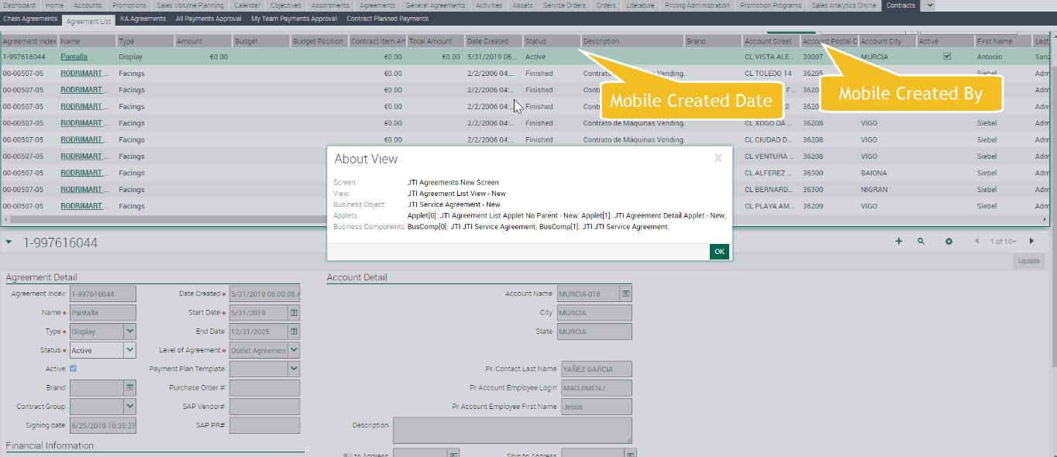

* Payments Screens:

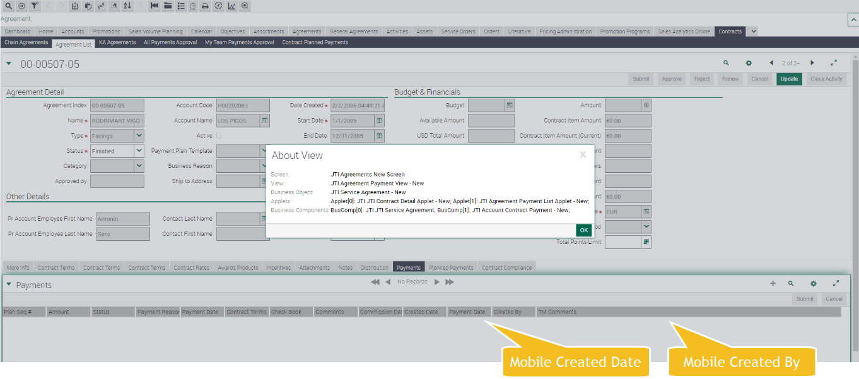

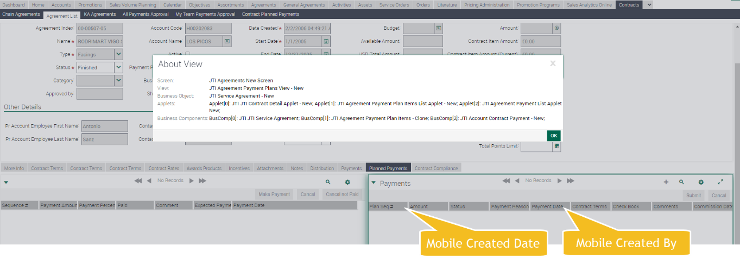

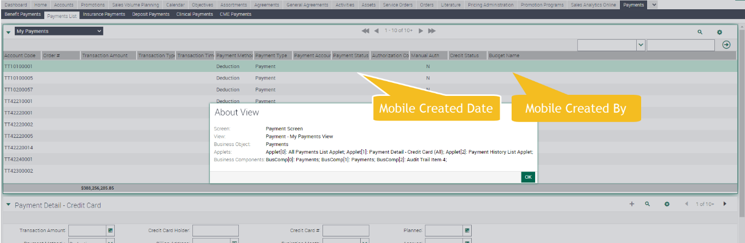

1. LOVS:

|  |  |  |  |  |
| --- | --- | --- | --- | --- |
| **Type** | **LIC** | **Display Value** | **Market** | **Language** |
| JTI_BENEFIT_TYPE | Payment | TBC | RUS | Spain |
| JTI_BENEFIT_TYPE | Payment | TBC | KZA | Italy |

## English Captions

|  |  |  |  |  |
| --- | --- | --- | --- | --- |
| Type | Format | Caption ENU | Language | Caption LOCAL |
| JTI Target Num | Numeric | Target | ENU | Target |
| JTI Target Num | Numeric | Target | SLK | Target |
| JTI Mobile Created | DateTime | Mobile Created | ENU | Mobile Created |
| JTI Mobile Created | DateTime | Mobile Created | SLK | Mobile Created |
| JTI Mobile Created | DateTime | Mobile Created | HUN | Mobile Created |
| JTI Mobile Created | DateTime | Mobile Created | ITA | TBD |
| JTI Mobile Created | DateTime | Mobile Created | ESN | TBD |
| JTI Mobile Created | DateTime | Mobile Created | CSY | TBD |
| JTI Mobile Created | DateTime | Mobile Created | RUS | TBD |
| JTI Mobile Created | DateTime | Mobile Created | KZA | TBD |
| JTI Mobile Created By | Text | Mobile Created By | ENU | Mobile Created By |
| JTI Mobile Created By | Text | Mobile Created By | SLK | Mobile Created By |
| JTI Mobile Created By | Text | Mobile Created By | HUN | Mobile Created By |
| JTI Mobile Created By | Text | Mobile Created By | ITA | TBD |
| JTI Mobile Created By | Text | Mobile Created By | ESN | TBD |
| JTI Mobile Created By | Text | Mobile Created By | CSY | TBD |
| JTI Mobile Created By | Text | Mobile Created By | RUS | TBD |
| JTI Mobile Created By | Text | Mobile Created By | KZA | TBD |

Translations from previous CHGs

|  |  |  |  |  |
| --- | --- | --- | --- | --- |
| Type | Format | Caption ENU | Language | Caption LOCAL |
| JTI Total Amount Limit | Number | Total Amount Limit | RUS | TBD |
| JTI Total Amount Limit | Number | Total Amount Limit | KZA | TBD |
| JTI Total Amount Limit | Number | Total Amount Limit | SLK | Total Amount Limit |
| JTI Total Amount Limit | Number | Total Amount Limit | HUN | Total Amount Limit |
| JTI Total Amount Limit | Error message | Sum of Contract Total Amount exceeds in xxx the Total Amount Limit | RUS | TBD |
| JTI Total Amount Limit | Error message | Sum of Contract Total Amount exceeds in xxx the Total Amount Limit | KZA | TBD |
| JTI Total Amount Limit | Error message | Sum of Contract Total Amount exceeds in xxx the Total Amount Limit | SLK | Sum of Contract Total Amount exceeds in xxx the Total Amount Limit |
| JTI Total Amount Limit | Error message | Sum of Contract Total Amount exceeds in xxx the Total Amount Limit | HUN | Sum of Contract Total Amount exceeds in xxx the Total Amount Limit |
| Contract Item | Text | Contract Item | RUS | TBD |
| Contract Item | Text | Contract Item | KZA | TBD |
| Contract Item | Text | Contract Item | SLK | Contract Item |
| Contract Item | Text | Contract Item | HUN | Contract Item |
| Benefit Type | Picklist | Benefit Type | RUS | TBD |
| Benefit Type | Picklist | Benefit Type | KZA | TBD |
| Benefit Type | Picklist | Benefit Type | SLK | Benefit Type |
| Benefit Type | Picklist | Benefit Type | HUN | Benefit Type |
| JTI Accrued Amount | Numeric | Accrued | RUS | TBD |
| JTI Accrued Amount | Numeric | Accrued | KZA | TBD |
| JTI Accrued Amount | Numeric | Accrued | SLK | Accrued |
| JTI Accrued Amount | Numeric | Accrued | HUN | Accrued |
| JTI Planned Amount | Numeric | Planned | RUS | TBD |
| JTI Planned Amount | Numeric | Planned | KZA | TBD |
| JTI Planned Amount | Numeric | Planned | SLK | Planned |
| JTI Planned Amount | Numeric | Planned | HUN | Planned |

The specified setup for a Market should not affect the other Markets setup and/or validations.

## Changes in the ETL

* *Functionally explain the general ETL requirements, listing in the below table all the fields required to be moved to OLAP, using ENU labels if coming from Sales Application views.*
* *If not present already in the TME Sales section, application print screens are required.*
* *Hidden fields technically needed by the ETL (e.g. Ids, Foreign Keys) do not have to be listed down*
* *It is however crucial that all fields functionally required are listed and that help is offered for Technical Teams to derive the correct implementation in terms of transformation/logic.*
  + *Please clarify needed transformations (IF NULL SET to 0) or calculations (complex logic)*
  + *Any filtering required at extraction or inserting time.*
* *Kindly combine the info in the below table with written requirements to clarify the requirements.*

New fields to be included in the ETL and transferred to PBI.

|  |  |  |  |  |  |
| --- | --- | --- | --- | --- | --- |
|  | OLTP Source | | ETL | OLAP Target | |
| # | **Entity** | **Attribute** | **Transformation** | **Entity** | **Attribute** |
| 1 | Contract Items | JTI Target Num |  | Contract Items | JTI Target Num |
| 2 | Contract Compliance | JTI Target Num |  | Contract Compliance | JTI Target Num |
| 3 | Contract | JTI Legal Entity |  | Contracts | JTI Legal Entity |

## Initial Loads/Massive Data updates

* *Use the below table to specify the requirements for data updates:*
* *Please help to clarify filters by market, period, or other attribute (in the remarks column).*
* *A data update’s urgency is dependent on the fact an impacted field in the update is used in Siebel Sales or BI application logic. In case so, it will be defined as urgent and the update will be done immediately after the technical release, ideally during the outage.*

**N/A**

|  |  |  |  |  |  |
| --- | --- | --- | --- | --- | --- |
| Data Update | | | | | |
| # | **Entity** | **Markets** | **Periods** | **Urgent (ODC)** | **Remarks** |
|  |  |  |  |  |  |
|  |  |  |  |  |  |

*\*In case TME Sales or BI application logic relies on the data update, this must be set as urgent.*

New **Process to inform Contracted** **flag** in the APA (Account Product Audit), when there is an active contract in the account, where product is included the distribution list.

* 1. Triggers for this process:
     1. New contract is activated with products in the distribution list
     2. New APA records are generated
     3. Contract is no longer active. (End Date is reached or status is not Active anymore)
  2. Process should be able to be enabled by market, without any release dependence.
     1. Initial Setup for: Italy
  3. An initial Data Update might be needed for the TMEC markets when going live. (As of now only for Italy market)

*\*To be discussed if this process can finally be performed in the mobile app.*

*\*Process for SIS and Rotation Dates will be evaluated in Oct2022 release.*

## Performance test/Indexes creation

* *It is assumed that ETL Performance Analysis and optimization will be done in all cases which require it, especially in brand new tables. Please note BI performance optimization is not subject of this analysis. If it applies, list down the requirements / newly developed areas that require a performance test with reasonable volume.*

**N/A**

## Changes in BI

*It is mandatory to include examples of the reports that are expected using the new metrics/objects that will be created. These reports are needed to validate that the technical solution will cover the requirements and later to test the development.*

* ***For new metrics****, it is needed to include an example (attached to doc).* 
  + *The steps are: create one report with existing data and include the XML; export the data to Excel and include the new metrics as fields calculated in Excel itself. The calculated fields will be used to validate the values obtained with the new metrics in DEV and UAT.*
  + *If the new metric requested can currently be calculated in the report, it is also useful to have the current formula included in the report for validation.*
  + *Also see an example copied at the end of this email where the new columns were added as literals in the report to show where they would be.*
* ***For new fact tables and/or dimensions****, it is needed to specify which other existing fact tables and dimensions are expected to be used together with the new objects. This is what we call “cross fact analysis”.* 
  + *Example: new Fact – Contracted Vending Machine Compliance. Market could require mixing this new fact with Fact – Contract Vending Machine, Fact – Contract Vending Machine Labels, Fact – Contract and dimensions Contract, Label Products, etc.*
  + *This is extremely important because we can’t guarantee that the new objects will work with existing objects if this was not explicitly requested in the FD. In case the market requests new cross fact analysis later, it will be considered a new requirement and will be subject to risk analysis and release timing. If raised late or has high risk, would be left for the next release.*
* ***For new cross fact analysis related to existing objects****, it is needed to generate an example with similar format as the one attached. Create reports with the existing functionality, show the result returned currently (include XML), export it to Excel and create there the report expected after the CR implementation, putting the different pieces together.*

New field “Target” has to be available at the Contract Terms, and Contract Compliance entities to be included in their reports. Metrics/reports to be reviewed.

New field “Legal Entity Name” has to be available at the Contract entity to be included in their reports. Metrics/reports to be reviewed.

|  |  |  |  |  |  |
| --- | --- | --- | --- | --- | --- |
|  | OLTP Source | | ETL | OLAP Target | |
| # | **Entity** | **Attribute** | **Transformation** | **Entity** | **Attribute** |
| 1 | Contract Items | JTI Target Num |  | Contract Items | JTI Target Num |
| 2 | Contract Compliance | JTI Target Num |  | Contract Compliance | JTI Target Num |
| 3 | Contract | JTI Legal Entity |  | Contracts | JTI Legal Entity |

## Data Dictionary

*New fields in BI should be added to the Data Dictionary. Actions below should be done:*

* *Business Description of the new fields (BTS TME) must be provided in this section.*
* *Fields should be added to the Data Dictionary DB Tables (ODC)*
* *In BI, Business Description should be configured to appear when mouse is over.*

Please, add next fields to the Data Dictionary:

|  |  |
| --- | --- |
| **Name** | **Description** |
| JTI Mobile Created | Date when record was created in mobile app |
| JTI Mobile Created | User that created record in mobile app |

## Changes in Data Interfaces

*Populate the below table with the information of the new inbound/outbound Interfaces requested, specifying:*

* *OLTP or OLAP | Entity | Interface Code*
* *Fields requested (or new fields to be added in new version)*
* *Explain the logic behind each field, if there are any remarks about its incoming format, required transformations, data type (to keep this simple, we use String, Number, Date, Datetime, Time, LOV)*
* *Add extra information about schedule (Nightly ETL, One-time, other custom schedule) in this section.*
* *For Outbound interfaces add Business Rules:* 
  + *specify the source system conditions for a record to be exported*
  + *specify the post-export actions required to set records as exported*
* *Repeat this information for each interface, do not mix requirements.*
* *Combine the info in the below table with written requirements to clarify the requirements.*
* *Ensure you add a note in FD in case a new OLTP Interface may have impact in Siebel Remote Transaction Backlog, so that Technical Teams consider the risk in the design. Anything that will massively update or insert in OLTP is a risk for Transaction Backlog. As well, please consider a massive execution of the new process in the Use Case section, as this will be replicated in the CHG’s Test Script.*

## Inbound

|  |  |  |  |  |  |
| --- | --- | --- | --- | --- | --- |
| Inbound OLTP Contract Items – CI | | | | | |
| **#** | **Entity** | **Field Name** | **Contents** | **Data type/format** | **Transformation** |
| 1 | Contract Item | JTI Target Num | Target Num | Numeric | N/A |

|  |  |  |  |  |  |
| --- | --- | --- | --- | --- | --- |
| Inbound OLTP Contract Items – CH | | | | | |
| **#** | **Entity** | **Field Name** | **Contents** | **Data type/format** | **Transformation** |
| 1 | Contract Header | JTI Legal Entity | Legal Entity | Text | N/A |

## Outbound

Due to migration of KZ market from contracts old module to new module, market will be using Payments instead of Payment Plans entities, so following changes should be applied, in order to read from Payment Plan entities. This new version of Interface should be enabled for the market, once they go live with the migration to new module.

|  |  |  |  |  |  |
| --- | --- | --- | --- | --- | --- |
| Outbound OLAP Payments – PM | | | | | |
| **#** | **Entity** | **Field Name** | **Contents** | **Data type/format** | **Transformation** |
| 1 | Payment Plan | CX_AGR_PL_ITEM .X_PAYMENT_SEQ_NUM | Retrieve same column by using join S_SRC_PAYMENT. X_PAY_PLAN_ID |  |  |
| 2 | Payment Plan | CX_AGR_PL_ITEM .X_PAID_TYPE_CD | Replace with S_SRC_PAYMENT.PAY_STAT_CD |  |  |
| 3 | Payment Plan | CX_AGR_PL_ITEM .X_PAY_PERC_NUM | Remove from Interface |  |  |
| 4 | Payment Plan | CX_AGR_PL_ITEM X_EXP_PAY_DT | Remove from Interface |  |  |
| 5 | Payment Plan | CX_AGR_PL_ITEM X_OBSERVATION_DT | Replace with  S_SRC_PAYMENT.ACTL_PAY_DT |  |  |
| 6 | Payment Plan | CX_AGR_PL_ITEM X_ACT_AMT | Replace with  S_SRC_PAYMENT.PAY_AMT |  |  |
| 7 | Payment Plan | CX_AGR_PL_ITEM X_PAY_AMOUNT_NUM | Replace with  S_SRC_PAYMENT.X_PLAN_AMT if informed, otherwise retrieve same column by using join S_SRC_PAYMENT. X_PAY_PLAN_ID |  |  |

Include new fields on the outbound interface to export Payments (In case only being used by Canada, not needed)

|  |  |  |  |  |  |
| --- | --- | --- | --- | --- | --- |
| Inbound OLTP Contract Items – PE | | | | | |
| **#** | **Entity** | **Field Name** | **Contents** | **Data type/format** | **Transformation** |
| 1 | Payments | JTI Mobile Created |  | Date Time | N/A |
| 2 | Payments | JTI Mobile Created By |  | User | N/A |

## Initial Loads

*Specify requirements for initial data loads if required.*

N/A

## Performance test / Indexes creation

*Specify requirements for performance test or indexes creation if required.*

N/A

## Changes in Batch Processes / Aggregations / DRP

*This section will be used for specifying requirements different to pure ETL tasks or Inbound or Outbound interfaces. It is assumed that these processes are not trivial and require transforming data in a complex way. Therefore, functionality will be explained by means of*

* *List of written requirements, in case requirements are not too complex and their written specification is not vague*
* *Pseudo-code / basic flowchart diagram (available in every Visio installation)*
* *A combination of both*
* *Always using ENU Names of TME Sales or BI application fields and agreed entity names as per TME ENU application or BI subject areas.*
* *Please ensure you add a note in FD in case a new OLTP Batch may have impact in Siebel Remote Transaction Backlog, so that Technical Teams consider the risk in the design. Anything that will massively update or insert in OLTP is a risk for Transaction Backlog. As well, please consider a massive execution of the new process in the Use Case section, as this will be replicated in the CHG’s Test Script.*

N/A

## Use Case

|  |  |  |
| --- | --- | --- |
| Role  *Trade Marketer, ASM, Local Admin…* | Application  *Sales, Analytics, ETL, Batch, Interface* | Step  *Description of the step and its expected output* |
| Local Admin | Sales | Navigate to Contract Templates - Terms:   * Review that field Benefit Type is no longer required.   Navigate to Independent Contracts -Terms:   * Review that field Benefit Type is no longer required. * Review that new field Target (numeric) can be informed. * Review thar Distribution applet is hidden   Navigate to Contract – Compliance screens:   * Review that new field Target (numeric) can be displayed (Read Only).   Navigate to KA/Chain contracts:   * Review that field Benefit Type is no longer required. |
| Local Admin | Sales | Review that a field Legal Entity is available in the Contracts form, for Independent, KA and Chain contracts. |
| Local Admin | Sales | Review that Contracted flag in APA records is informed for Italy market, when a new contract is activated |
| Local Admin | CHG213427 & CHG213127 | Ensure that functionality for these CHGS has been enabled for the following markets   * Czech * Hungary * Slovakia * Russia * Kazakhstan |
| Local Admin | Outbound interface CI, CH | Ensure that fields on the interface have been updated correctly. |
| Local Admin | Outbound interface PM, PE | Ensure that fields on the interface have exported records correctly. |